West Los Angeles Athletic Dept. Development Survey 2016 – 2017 Summary
(Fall/Winter Sports Only) Sport Specific
https://docs.google.com/forms/d/16Nrc_jDoVacHQRdwO4-xE6keL7CtrHIXUZuV8doq2Yw/edit#responses
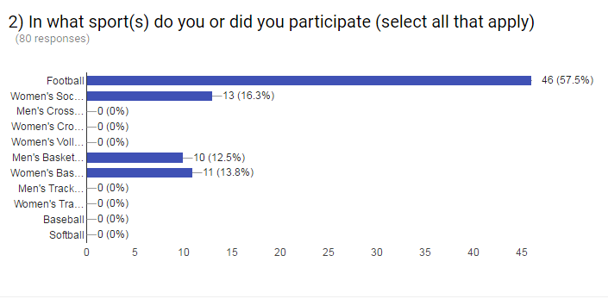
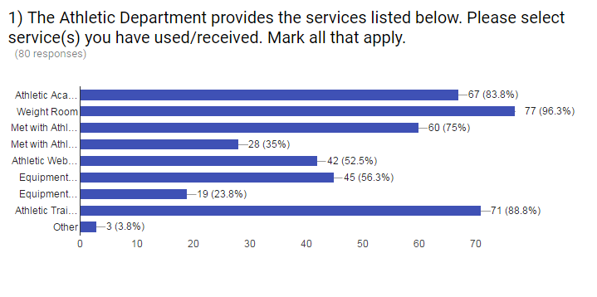

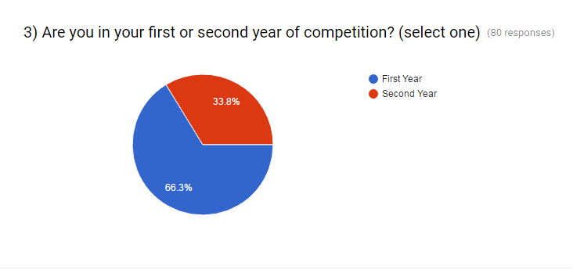

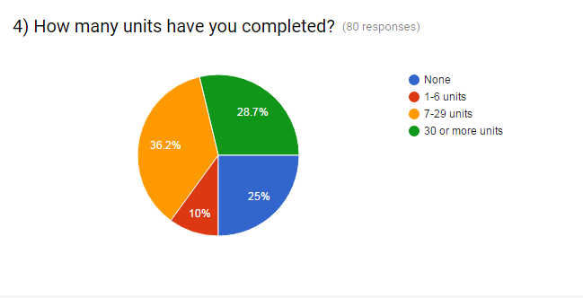
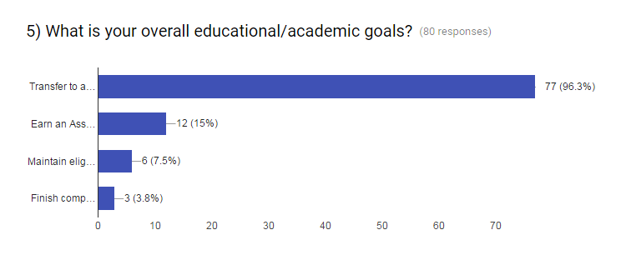

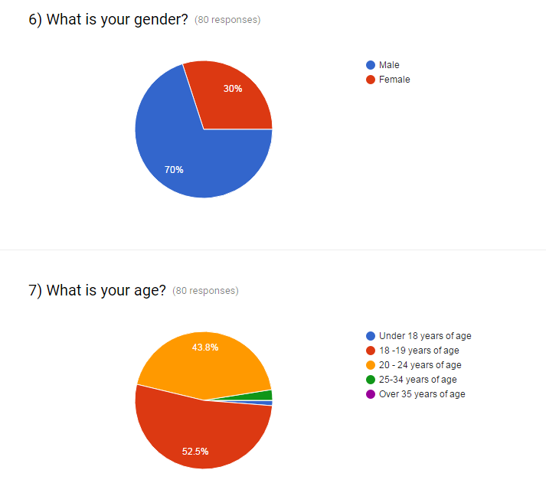

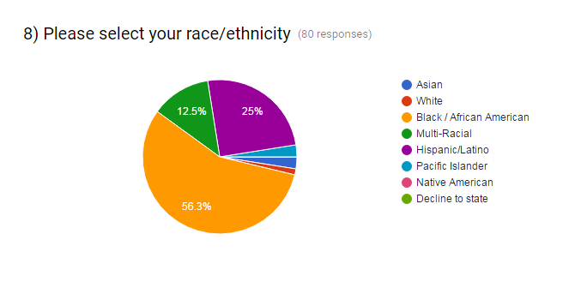

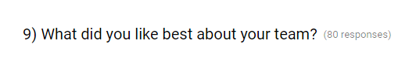
- Accepted me like family
- Being able to work together as a team and also study together
- Bing able to get along with team
- Can't say
- Chemistry
- Chemistry, we all wanted to win
- Competitiveness
- Everybody was serious and competitive; hard work
- Everyone got along. Team talks after each game
- Everyone is family, uplifting, and competitive
- Everyone seemed to get along for the most part
- Everything and how we work hard
- Family
- Good athletes
- Good talent, get along well
- Having fun while we played football together
- How I met some of my close friends only 2
- I like how we got close in a short amount of time
- I like the team's competitive nature and desire to win each game
- I liked that even though everyone had their differences, at the end of the day we were all cool with each other. I feel like there was no separations
- I liked the energy on the team
- I was a starter
- IDK
- Jokes; everyone was given a chance to display their talents
- Just the people on it
- Meet new people
- Most of us got along with each other
- My brothers are together
- My teammates
- My teammates, we got along very well on and off the court
- One heartbeat
- Team atmosphere; coaches
- Teammates
- That even though we went through this hard season the ones who stuck through it and the ones that came was positive through it all.
- That I have a close bond with a handful of people on my team
- That some of use get along not all but some pretty cool people I've met this year
- That we all got along and didn't have no fights or break apart and attack each other
- That we talk and hangout on campus and that we got each other’s back
- That we work together
- The coaches and the quality of the teams away jersey
- The community
- The friendships that I made with some teammates
- The gear & Coaching Staff
- The girls were very warming to having soccer girls come out
- The overall chemistry we share as a football family
- The players
- The players from the basketball team are friendly
- The team bond
- The teammates, team chemistry, and coaching
- They are great at encouragement
- They are helpful
- They cool
- They showed me the ropes of college football
- They were all welcoming of the new players and it felt like family
- WE all hoop
- We all want the same thing when it comes to football and also we became a brotherhood
- We always played as one
- We are family
- WE competed on a high level
- We competed, we had fun, finished games no matter what the score was
- We could beat anybody when we played as a team
- We got along with each other
- We had some good times
- We have chemistry
- We played as one
- We was a family
- We were sneaky good
- We worked together no matter the situation
- When I first joined the team, everyone was super welcoming and I made friends within the first week.
- Winning
- Winning

- Always work with people attitudes. Remind them to leave the problems out and just enjoy the game
- Be more as a family
- Become more responsible; Better practice equipment
- Better coaching
- Better coaching staff/equipment
- Better communication; Team chemistry
- Better drills during practice and better strategy during games
- Better structure for both sides of the ball; Stop the excuses and more accountability; Players with heart
- Better weight room
- Better, more experienced coaching staff
- Cheer each other
- closed practice offers for new players outside the current lineup
- Coaches need to work on positive reinforcement and constructive criticism, players need to be more accountable and not point fingers when things go wrong
- Commitment, no back talk
- Defense
- Don't argue as much be more polite to each other
- Equipment
- Everyone be more dedicated in the off season
- Get a better coaching staff
- Get new DB coach and defense coach
- give everyone a chance
- Have more players
- Have more structure and leaders
- Have more team activities outside of the gym like a trip to the movies etc.
- Helping one another
- Het better helmets , uniforms, and shoulder pads
- home jerseys
- IDK
- Leadership, roles, and teamwork
- Making sure we don't have any girls with a bad attitude
- More discipline
- More discipline
- More focus, Hell week would bring players closer together; Coaches keep riding players to keep stutter
- More recruitment
- More recruitment
- more team building
- Music during weight room
- My suggestion for team improvement is to work as a team not fight and argue with each other. I feel like instead of arguing we should work as a team.
- No messing around
- no suggestions
- none
- nothing
- Nothing
- persevere; Never give up
- Show up to practice and be on time
- Some players should work on having a positive attitude and self-discipline. If people work on these, then the team can be stronger than ever
- Stay focus
- Stay focus
- Stay together as a team
- Stick together more through tough times
- Suggest getting everyone on the same page early to prevent misunderstandings
- Teach second and third strings more
- Team chemistry
- Team chemistry
- That people need to separate outside drama when they come onto the field
- The overall handling of emotions was awful. I think players need to convey their message more clearly
- To have more ability for gym access and weight room
- To value players who show up to practice and have them participate more during games instead of benching them. Better individual feedback and training based on players’ position. coaches keeping their word and not promising things that they can’t or won’t do
- Way more practice time and gym access
- We need team leaders who take things seriously
- We need to get stronger. We need to stop having excuses, stop missing practice, uplift one another and keep our composure
- Work hard; Don't get distracted with anything that doesn't concern with football
- Work harder
- Work harder
- Work harder
- Work more as a team
- Work more as a team and don't drop our heads so fast
- Working together as a team
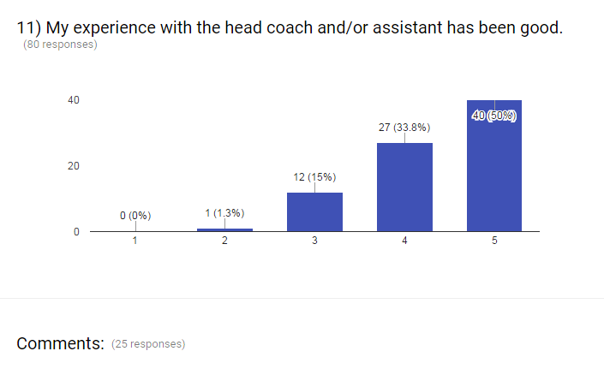

- Both coaches are amazing people. However, sometimes it seemed as if the team couldn't be controlled or as if one of the coaches had trouble getting their attention
- Coach Cody is chill and cool, so he's my favorite
- Coach Jones is a player's coach
- Coach Jones smoove
- Coach Miller is my dawg. I can't get down with Coach Richardson, that fool is loony
- Fun to be around
- Good staff
- Greatest coach
- Head coach
- I enjoyed the coaches attitude/ Even at times that we didn’t do good, they didn’t make me feel too bad o yelled at me in front of everyone which it was good
- I have very strong bond with the assistant coach (Cody) my bond is not great with the head coach. Coach Rob teaching skills need to be improved and he needs to be more open minded
- It's only neutral because I don't like being yelled at when I'm asked a question and being told to shut up by some coaches
- Learned a lot this year from coach Jones
- Majority of the coaches are the best one or two need to be taught how to coach
- Miller cool
- My coaches were good to me
- Never gave up on me
- Only took control when they felt like it
- There should be more feedback individually
- They are great coaches
- They have helped me with whatever they can
- They were all helpful
- They're here to teach us and that's what they do. Sometime life lessons and other things we could improve on in sport lives
- Tells me the right things to so while in practice, game, and off the field. Assistant a good coach to keep you on your game
- Twan is a good coach even though we work a lot it always benefits is in the end
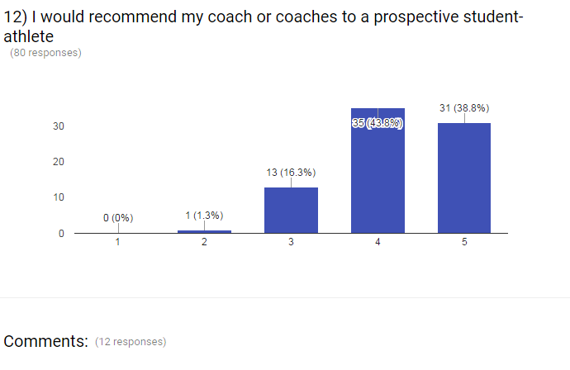

- A coach that knows what he is talking about
- All the coaches push the players to be the best they can be
- Both coaches strongly believe in academic success and this is very important for a student-athlete
- Depending on position
- I would only recommend Twan and Jocylin because they are patient and Twan know how to get us in shape and is fair
- I would recommend one of them, idk bout the brother
- I would strongly recommend Coach Cody to any student athletes. Coach Robinson on the other hand is debatable
- On offense I agree
- Only some of them
- The know what they are doing
- Wanting to improve and become better they can help with that
- We lost girls throughout the season and I felt my coaches gave up on us for a while but we were able to turn that around and rebuild through the season

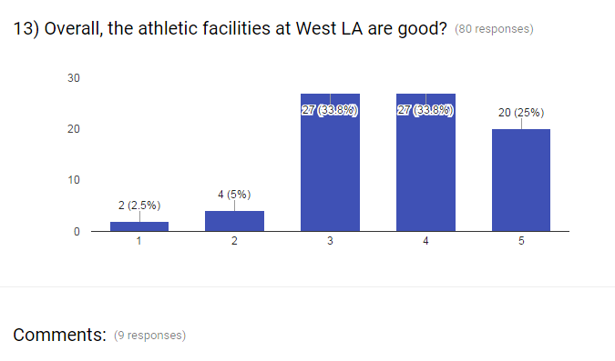

- Better weight room equipment & more help in the athletic clinic
- Cold improve study all and weight room
- Home jerseys are terrible
- I think we could improve greatly on weight room equipment
- Need another basketball court, had to share w/volleyball; have access to shooting machines, 24 access to basketball gym
- Nice field but weight room is dirty
- The A.D. is doing a great just after one year at West LA, he se see a great future in West and happy he here
- The floor is pretty dirty in the gym
- We could use more people in the athletic room. Vic and Allison are great! We just might need to add a couple more. We all like Alison
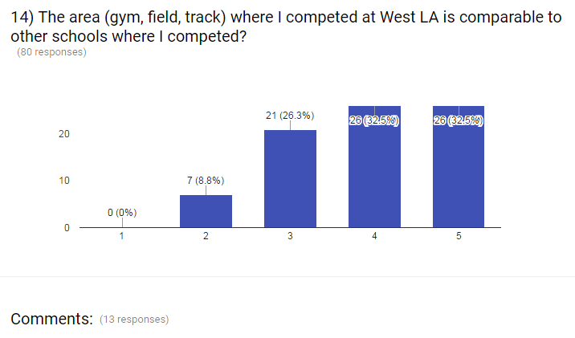

- Except the gym area
- Facilities are standard
- I felt like our facilities lacked something compared to other schools such as bigger athletic training room, lights for fields
- Just dirty gym floor
- No lights, one set of stands
- Other schools have things to help them improve like shooting gun/ vertimax
- Some schools we competed at gyms were a little more advanced (air conditioning) and courts
- Sometimes the court wasn't cleaned which made it slippery
- The field and track are great. The weight rooms need a lot of work
- The floor is slippery and its really hot compared to other gyms
- The other school gyms where more updated with the gym and clock
- West gm is ok, floor is slippery, dimly lit
- Yes somewhat. We need lights though

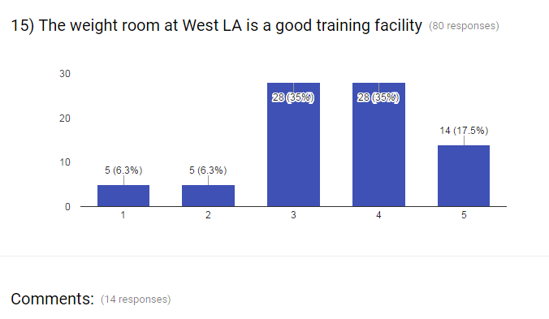

- Better equipment
- But we hardly used it
- Kind of dirty and a lot of things are broken
- Need new things
- Needs a lot of improvement
- New weights
- Nothing good at all. Nobody take care of the room. Baseball players
- Some machines were broken, but other than that great experience
- Some of the equipment is broken and missing weights
- Some weights would be missing
- The fitness room foot pedals need to be replaced
- The weight room could use an upgrade as a full set of weights in each weight room
- They didn't have a set of dumbbells at times so my teammates would use heavier weights or lighter weights than usual
- Things are broken, missing weights and it is dirty
Recommendation
- Remodel all Weight Room areas
- Update and replace all missing equipment

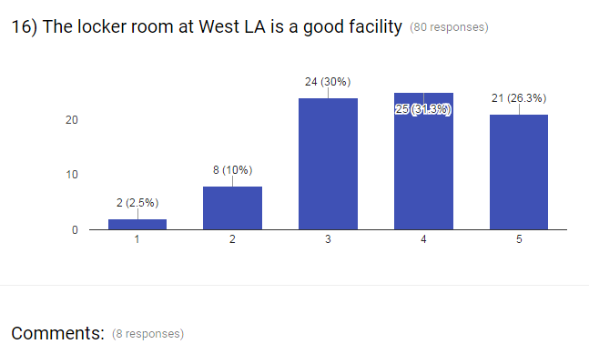
- Decent enough
- Haven't been in there
- It's ok
- Janitor keeps it clean when team struggles to
- Looked like something died in there
- Showers could be cleaner
- The showers could be cleaner. And not all showers work, but the rest of the room is clean
- Zulma doing a good job by keeping it clean and providing us with equipment
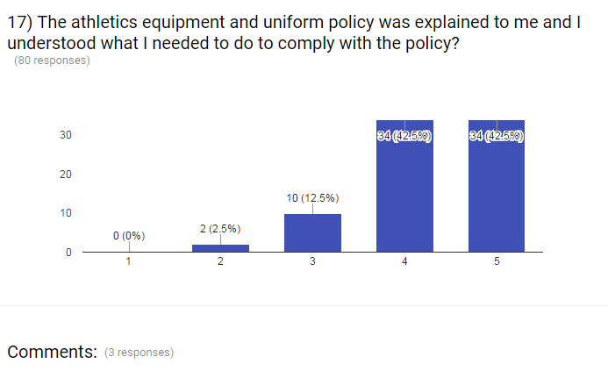

- Better helmets
- Yes
- Zulma is great

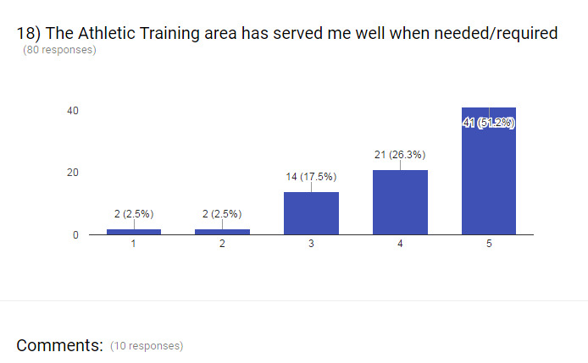

- Alison doing a very good job helping Vic
- Allison and Vic work amazing together, but they can use more help. There are way too many athletes
- Always there when I was in pain. Thank you
- I love Vic and Alison
- It does get I believe more help is needed
- It has served me well but it needs more people
- Need assistance & AC always hot
- Need more help in the training room
- They are always following up with you after an injury and are very caring
- They had me feeling right
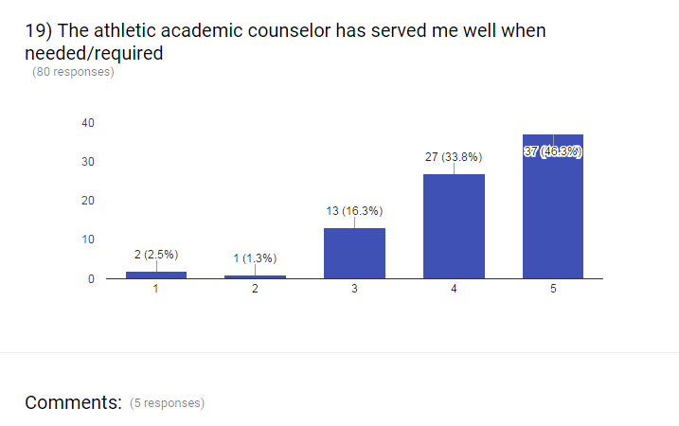

- For someone who came late, the counselor has really helped me
- I guess
- Lily was a great replacement for Mr. Samilton. He would be happy to see her in his position
- Never here
- Very helpful

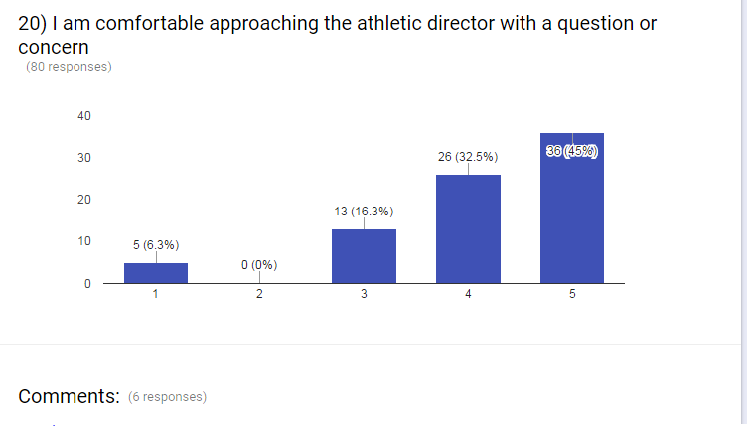
- Hard to find. As in don't know the location of A.D all the time
- He doesn't seem to show support for our w/soccer program
- He doesn’t show enough support for our team like he does to others. He doesn't even communicate with some of the athletes or even knows about them like the others counselors do
- I never really talked to the AD 1on1. But he is a really nice person
- Not really
- Very helpful
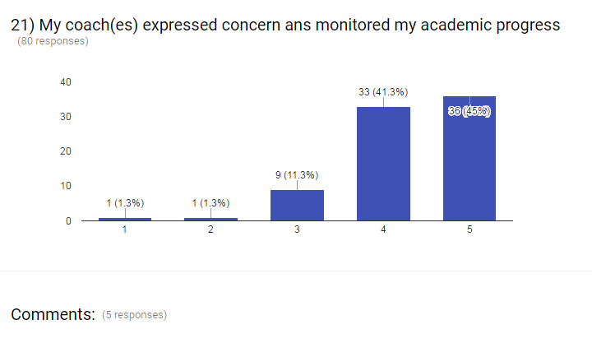

- Always
- Always contacted us and made sure we had our classes and up with our units
- Coach Miller
- Coach Miller keeps up with me
- Worries about academics more

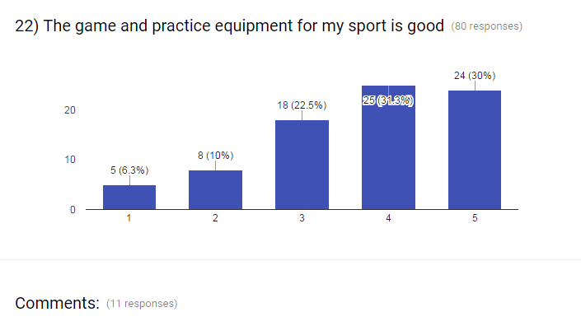

- All the equipment is great and in good condition
- Bad shoulder pads and helmet
- Its ok, but needs better
- Late comer’s soccer girls barely got gear. I am too small to fit any of the gear West has
- Need more equipment
- Need more equipment to help out athletes
- Need newer equipment helmets etc.
- Not enough practice shorts
- Our game outfits, hopefully we can get new ones
- Practice gear is outdated
- The basketballs are kind of old and slippery

Recommendation
- Inspect all uniform and team equipment
- Have coaches evaluate the most needed items
- Replace all damaged equipment and uniforms by season

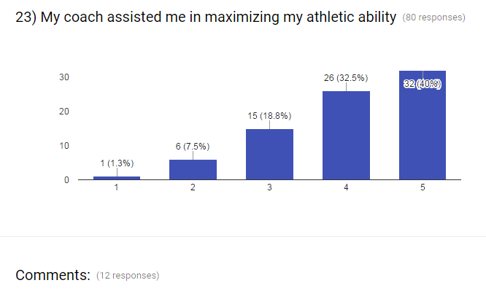
- A few coaches
- Assistant Coach Cody helped me more through the season
- Before joining the team, I was not fit and lacked self-confidence. However, thanks to Coach Amber and Coach Cody I have improved and developed.
- Being fairly new to playing, my progress in playing has become better
- Better one on one training
- Feel like we can do some more skill things to improve our game
- Helped me get stronger
- I've never played competitive basketball, but they made the transition easy
- My coach is always ready to prepare girls or the next level
- Not the DB coach
- One coach did, not the other
- Only worked with his favorite players
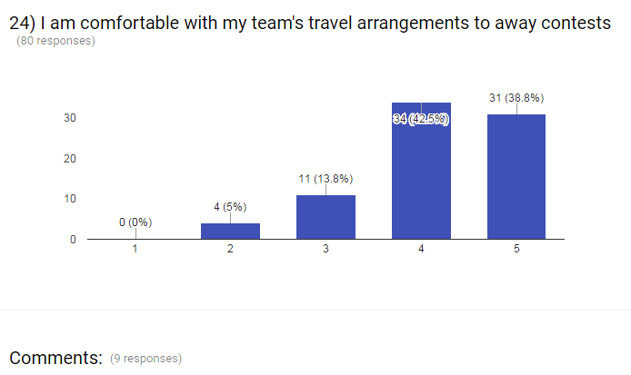

- Amazing
- Not with the food sometimes that we have to eat
- The van do not have AC, the lock is broken. Not enough player space
- The AC in one of the vans needs to be fixed
- The school vans are old and they get very hot and stuffy
- The vans are tacky and its hot in the vans
- The vans need to be fixed. One doesn't have AC and another has messed up locks
- The west vans were too small
- Yes
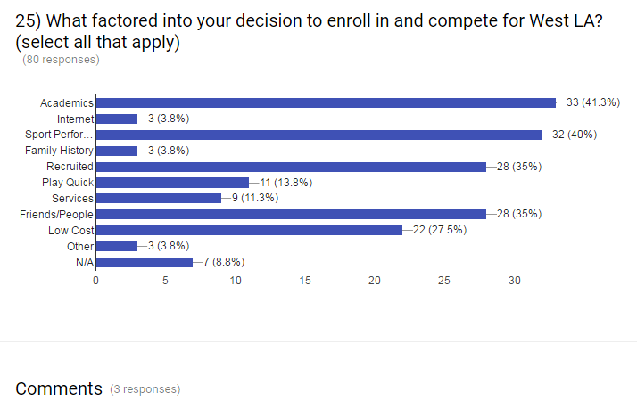

- Coach amber made me come here and compete
- It was close
- Location

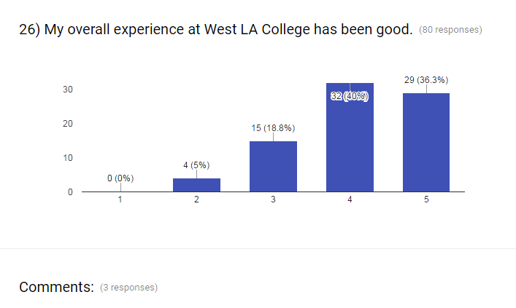

- I had the time of my life
- Only because I'm close enough of getting my AA
- Went to SMC for a few years and I believe WLAC is a way better college environment
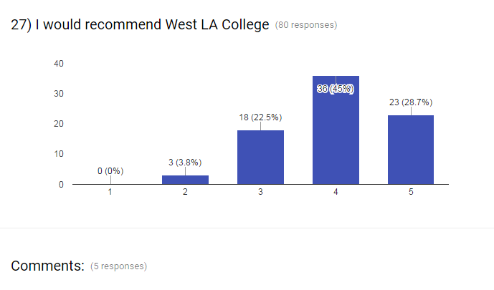
- Coach Miller is a good head coach
- Depends on what the person is looking for
- It's a great small school that challenges students in every way
- Only because of football
- Yes is a small school. Easy to get around

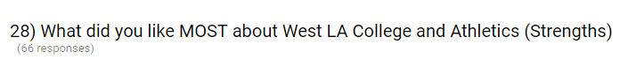
- All teams supported each other. These teams and staff of athletics were very helpful
- Assistance with me education; strengthening my awareness on the football field
- Coach always pushed me to do better. She talked to me whenever I needed to improve something and always mentioned that grades are very important
- Coach Cody & Coach Amber; Coach Twan/Jocelyn/Mats/ Ben; Soccer was competitive
- Coach Miller and how he runs things
- Coach Miller has taught me a lot in my time here
- Coaches; Team unity
- Easy going atmosphere
- Easy to park, low cost, not hard to get classes
- Everyone in the department is very welcoming and kind. I had great experiences with my coaches and the athletic academic counselor.
- Friendly
- Get better
- Good cheap Gatorades from Vic
- Good coaching
- Good coaching. They make sure you do well in and out of the classroom
- Good experienced coaching staff; Plays guys that can help the team
- Good schooling environment
- Good team ambience
Friendly relationships with coaches
- Great coaching staff
- Having a good coach that respects me
- Head Coach
- Help gets you a scholarship
- How everybody was successful and being serious
- How everyone gets along
- How they were nice
- I feel like all the sports here are close to each other in different ways
- I honestly think is a wonderful experience. West LA college provides a lot of resources
- I like how most of the coaches & players were really nice and patient with the freshman like myself
- I like how we have our ups and downs and we can still talk and get better
- I like that it is a chill environment. Some of the athletes are nice and friendly
- I like the atmosphere gives players more freedom then some other colleges may not
- I like the environment and everything has opened my eyes to stuff
- I liked Coach Reid and Coach Mills
- I liked how the assistant coaches helped me on my game. I feel like I've improved a lot since coming here.
- I liked the athletic trainers, my team and coaches, the conference, the athletic counselors
- It being clean
- It is very close to home and they care about each and every one of their students
- It was pretty good I can say
- Lead role
- Miller was real, Reed was cool
- No matter what we came together as a team
- Nothing
- Professors atrium understanding and helpful
- Small campus, keeps you out of trouble
- Smaller college, know everyone. All sports are family
- Teachers who won't to give up on you because they been where I am before. The athletics also
- Teamwork, seriousness, academic help
- That being an athlete here means a lot
- That it is a good program
- That you build a family close friends here at west
- The coaches and how concerned they are and train us to be the best we can be
- The coaches are great and being w/players
- The facilities were good
- The facility is wonderful
- The field is beautiful and I like the whole idea of the SAAC committee
- The football program
- The guidelines you have to follow so everyone is discipline
- The players were cool and the coaches
- The staff is really nice and helpful. Our field is also really nice and I enjoyed competing on it
- The team was good and I got along well with the team. The coach fit my personality
- The workouts
- They try to improve
- We had a great athletic trainer
Being an athlete
- We worked together
- Well prepared great people all around love the environment
- What I like most, was how everything was organized& how the athletic counselor really helps you
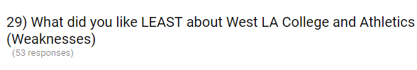

- A few coaches
- Athletic counselor
- Better equipment
- Can't argue
- Coach needs to be more discipline and not favorites
- Could invest more on wheels for goal posts
Could improve weight room to accommodate entire athletic teams needs
- Could of done better with the athletic counselors this summer
- Defense not on the same page; DB coach was a weirdo
- Equipment
- Equipment
- Equipment
- Everything dealing with budgets
- Football program
- Hours in the gym could help
- How everyone is just in Vic's talking to friends and it get so packed that some athletes can't get treatment
- How some teachers and athletics come here from a 4 year an act like they better when they in the position we in
- How the other teams don't show enough support for others. Why have a wild west and have some teams go and watch them play if they can't even come to the other teams games at least for like 15 min
- I don't like how the coaches yell at you when they ask you a question and tell us to shut up. I don't like how we get $7 for our per diem for our away games. I never heard of this until after the season
- I loved everything
- I mostly only helped starters only
- I think the program can improve on teams actually supporting each other and being more active.
- I think we should do a better job at holding each other and ourselves accountable for doing the right things on an off the court
- I would rather our full per diem. The money we get when we travel, I would rather get the full amount rather than splitting it at places where we all might not enjoy
- Need more mandatory meetings with academic counselors
- Need to announce the game more. I know students want to be able to be at games but they don't know when the games are unless we announce the games.
- No encouragement, No opportunity, short leash
- Not a lot of room for improvement
- Other team wouldn't come to out to support us in our home games.
- Our equipment
- Practice uniforms
- Some of the coaching methods
- Some other teams can be supportive and also show off the athletes that are doing well in the sport. Give them the appreciation that they need. Victoria seems to be stressed and rushed when teams are in season, try to get him more assistance.
- Sometimes the trainer’s room was too crowded; Transportation in vans; Not a lot of other sports attend our games
- Somewhat unorganized, counselors had me take classes I didn't need
- The assistant coaches
- The coaching staff didn't meet expectations
- The equipment
- The equipment
- The per diem this year I didn't like I prefer getting the money and buying my own food instead of coaches buying us food for games
- The players handled their emotions like children
- The problems
- The weight room equipment
- The weight room needs better equipment. Specifically a football only weight room
- The weight room needs to be updated & we need more school spirit & advertisement
- The women's soccer team attends every game for other sports. When it came to the soccer games no one showed up. It’s happened two years in a row. and it probably happened plenty more times
- Tried 3 different shoulder pads, none were comfortable
- Trust
- Try to get more posters or flyers to help out with people supporting the athletic teams
- WE did not have that much access to the gym and we had limited practice time. We made mistakes in games that should be able to correct with more practice time
- We need to advertise more
- What I don't like about West LA is that they don't have a boy’s soccer team and softball team. Like there a lot of people that want to play those sports but can't because they don't have these sports. I also feel like athletes need to put a lot more effort in their sport
- Workout rooms
- Wsoccer goes to support other WLAC teams, but they don't come to support us. Coaching staff was lacking

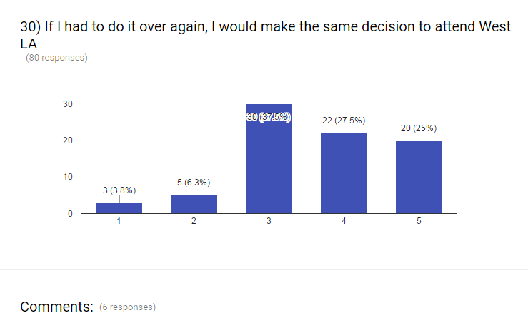

- 100%
- Coaching staff needs to be a good one. I feel the organization needs to find a good fit for the job. Don't just someone to fill in the spot. It just hire wastes time in the coach and the athletes time
- I'll probably come for units but to play sports probably not. The reason why is because some of the coaches are not even well experience and also didn’t have any recruits.
- Probably would've applied to some 4-year colleges had more self confidence
- The reason why I came here was b/c of Coach Amber and Coach Cody. When Amber left it hurt and I did not really agree with the head coach that was brought in
- Would of come here before southwest

