WLAC Athletic Web Page
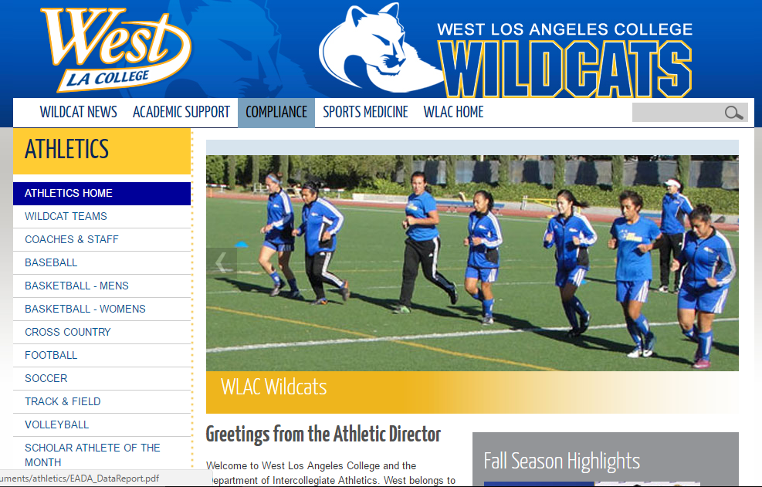
Popular Categories (All Drop Downs)
Sports
Includes all the sports within the program. This is constant on all of the athletic websites
Inside Athletics
This category includes the inner workings of the athletic department such as staff directory, mission statement,
Athletic training, sport camps, and athletic facilities (gym, fields, weight room)
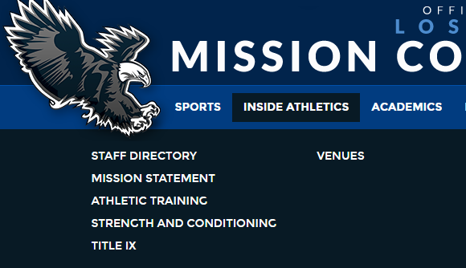

Academics
Will be the section where current and potential student athletes, to come and get all information about athletic counseling, Kinesiology degrees & certificates. Quick access link to West LA academic page. 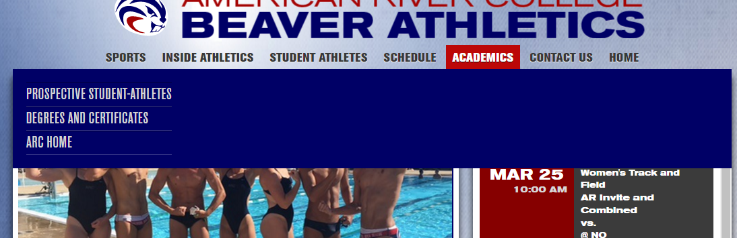

(Look for attachment of a Kinesiology curriculum)

Recruits
This is a section where student athletes should be able to come and contact coaches.
Ability to download all forms needed for athletic interest.
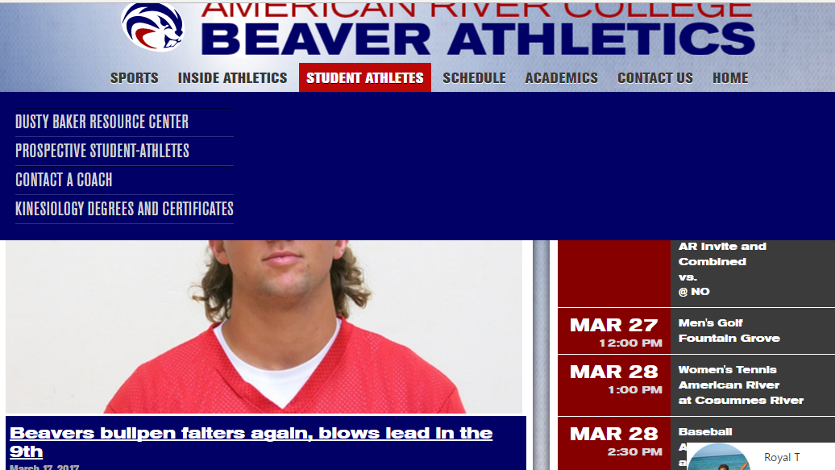

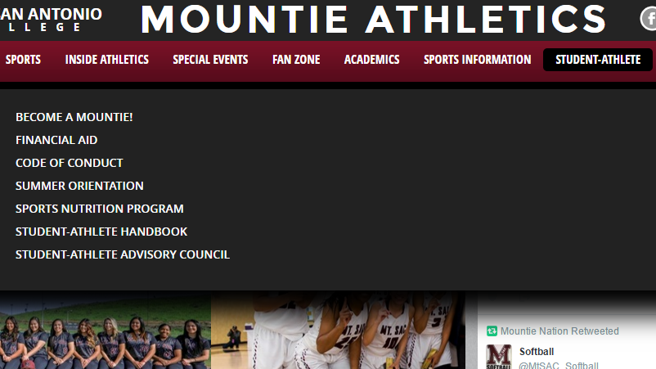

Support
Student support section, downloads, access to West LA Support, Title IX information

Alumni Section (Optional)
This is an optional section that I could be a great place to bring together the student-athlete alumni. Creating a base that could become more active within the West LA Athletic community

Team Store (Optional)
Opportunity to sell team apparel via the internet.
Giving a platform for student, family, and friends to purchase school gear outside of bookstore hours.

Sports Information
This section will provide direct contact information on sports information director, conference, league, and school statistics for all teams. Direct contact information for all local media and news outlets. Including WLAC Hall of fame lists, and Student athlete of the month lists of past and present.
New and current events that involves West LA athletes and staff.

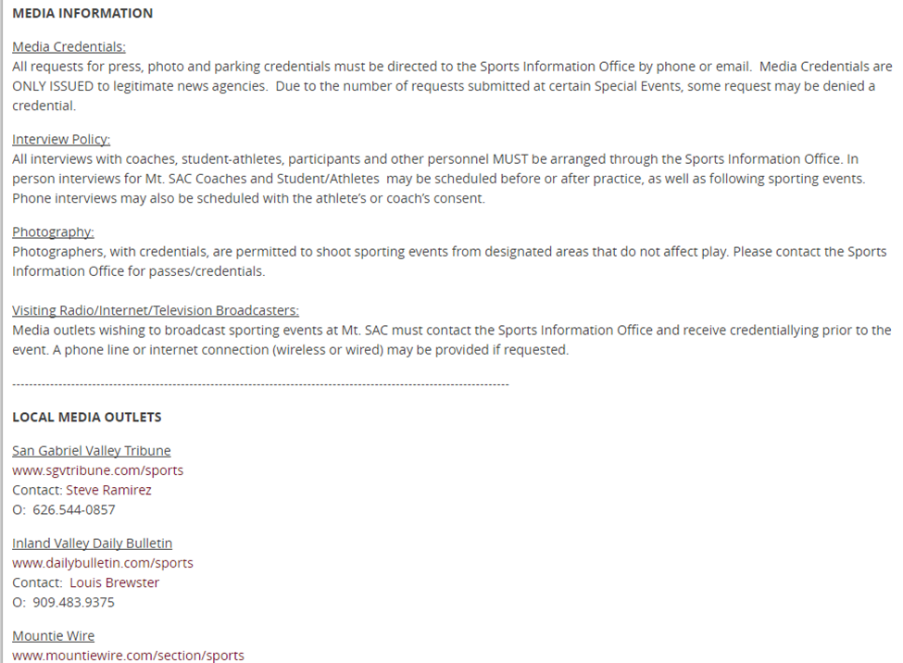

Special Events

All Athletic department functions examples include; Wildcat Golf Tournament, Holiday Tournaments, West LA WESPYS banquet.
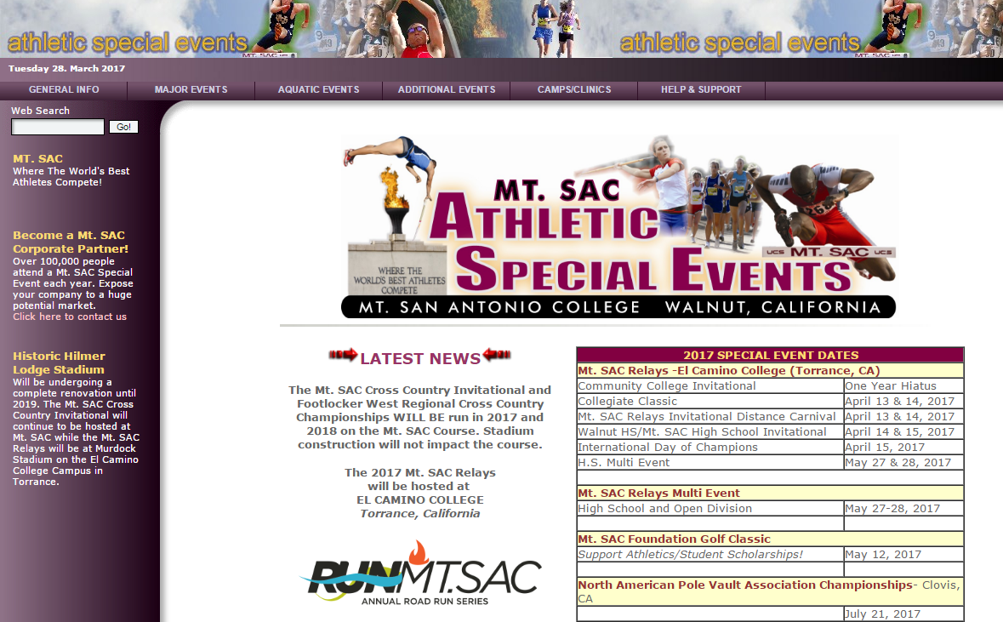

Social Media
A space where West LA social media presence is high & accessible via Social Media icons located on the first page of the athletic page.
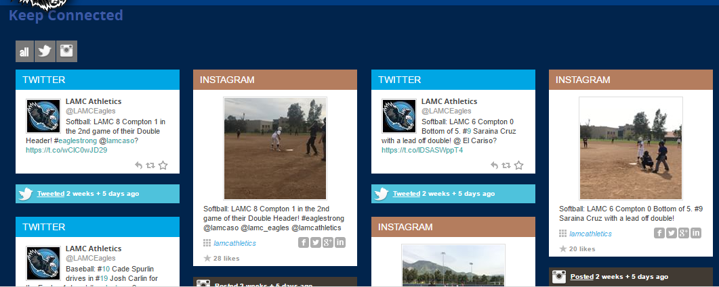

Calendar
Calendar should have its separate space or upcoming athletic events should be posted on the main page. Calendar should also have all upcoming athletic department special events that is open to the public.

CCCAA Conference Members Website

School Name | NATYCAA Rank | # of Sport | Website | Website Highlights
Fresno City | 1 | 21 | http://www.fresnocitycollege.edu/index.aspx?page=427
Mt. San Antonio | T2 | 22 | http://www.mtsacathletics.com/landing/index | User friendly, smooth transition into different categories
Riverside City | T2 | 20 | http://rccathletics.com/landing/index
Sierra | 4 | 18 | https://www.sierracollege.edu/athletics/index.php
Cerritos | 5 | 19 | http://cerritosfalcons.com/landing/index
Santa Barbara City | 6 | 19 | http://www.sbccvaqueros.com/landing/index
American River | 7 | 20 | http://arcbeavers.com/landing/index | Great Degrees and Certificate program curriculum
Golden West | T8 | 16 | http://www.gwcathletics.com/landing/index
San Joquin Delta | T8 | 16 | https://www.deltacollege.edu/athletics/index.html | Athletics resources Section Internship opportunities
Cuesta | 10 | 12 | http://www.cuesta.edu/student/forstudents/athletics/
Imperial Valley |  | 11 | http://athletics.imperial.edu/landing/index
LA City |  | 7 | http://www.lacitycollege.edu/athletics/
LA Mission |  | 5 | http://www.lamcathletics.com/landing/index/ | Page set up as if it has 22 sports great social media presence  This is very user friendly website.
LA Southwest |  | 3 | http://www.lasc.edu/athletics/index.html
LA Trade Tech |  | 8 | http://trade-techathletics.com/landing/index
Lake Tahoe |  | 2 | http://www.ltcc.edu/campuslife/athletics/index.php
Laney |  | 7 | http://www.laney.edu/wp/athletics/
Los Medanos |  | 7 | http://www.losmedanos.edu/athletics/
Marin |  | 10 | http://athletics.marin.edu/landing/index

Recommendations
- Look to add a few new categories mentioned above to West LA Athletic Website.
- Increase the social media presence. Many of the student athletes communicate, retrieve and share information this way. Ultimately increasing the number of views of WLAC Athletic website and college itself.
- The online footprint will be a great plug to increase the number potential sponsors. Opportunity to highlight corporate supporters.
- Establishing a photo gallery where photos can be purchased or shared.
- Updating the font of the website which would include font and dropdown option for selected categories (Limiting the opening page clutter)
- Including Kinesiology classes that lead to degrees and certificates within the department (American River College http://web.arc.losrios.edu/catalog/Kinesiology.pdf)
- Team pages should have same categories. All team pages need to be updated. (Updated team pages show that coaches and department care about their teams!)

